Config server properties: <https://github.com/msk4949/config-server-properties>

Config server: <https://github.com/msk4949/config-server>

Eureka Server: <https://github.com/msk4949/eureka-server>

Gateway Server: <https://github.com/msk4949/gateway-server>

Customer Service: <https://github.com/msk4949/customer-service>

Hotel Management Service: <https://github.com/msk4949/hotel-management-service>

Reservation Service: <https://github.com/msk4949/reservation-service>

Payment Service: <https://github.com/msk4949/payment-service>

Postman Collections: <https://github.com/msk4949/postman-collections>

Docker Compose yaml : <https://github.com/msk4949/postman-collections/blob/main/docker-compose.yaml>

Design Implementation:

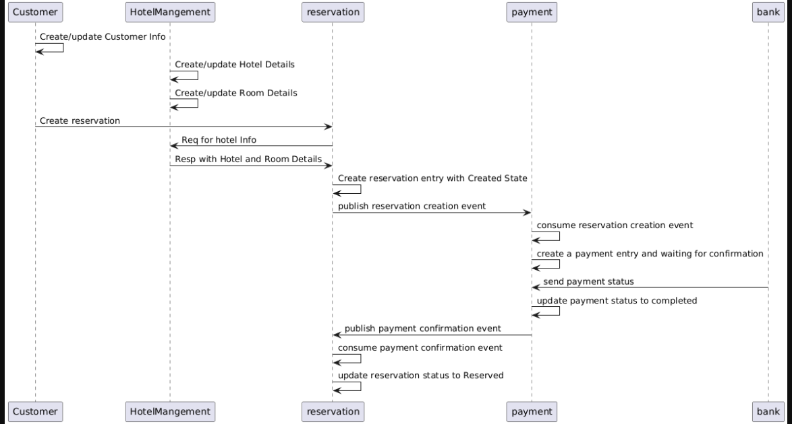

Eureka server with app details:

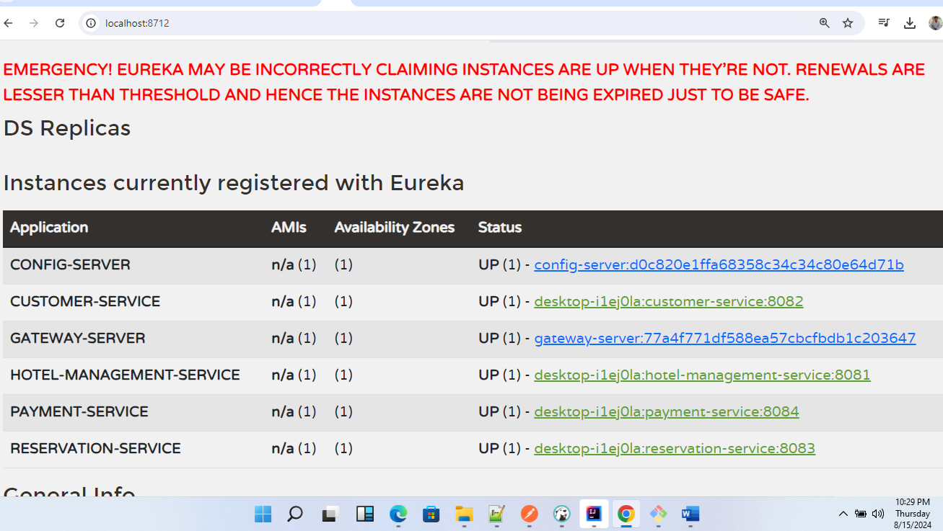

Zipkin dependency Diagram:

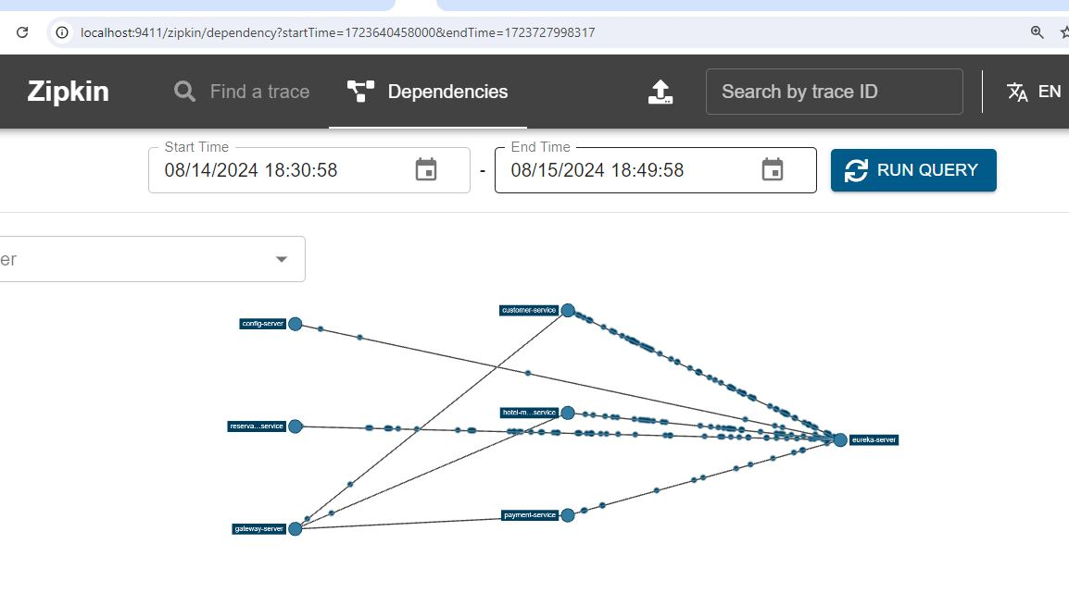

Postman req setup:

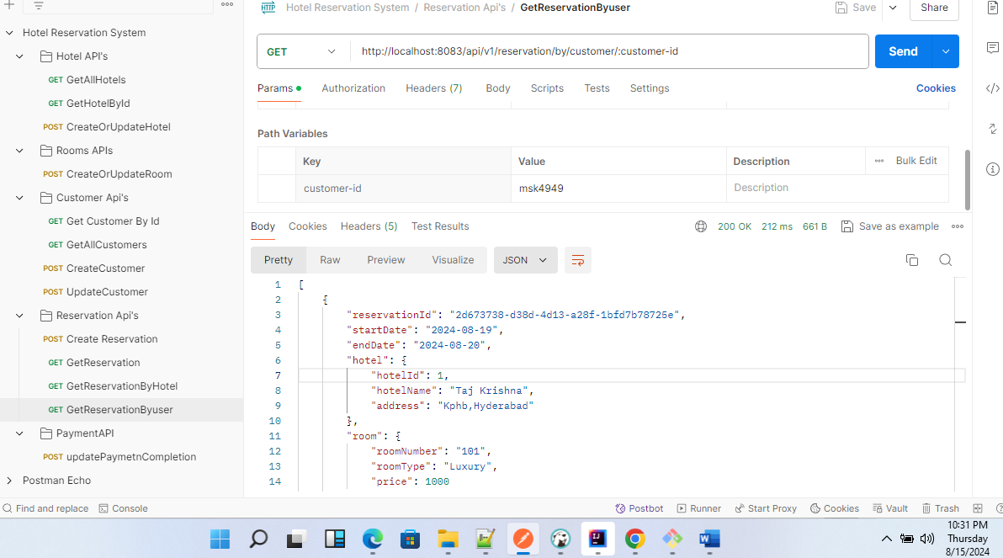

Database schema overview

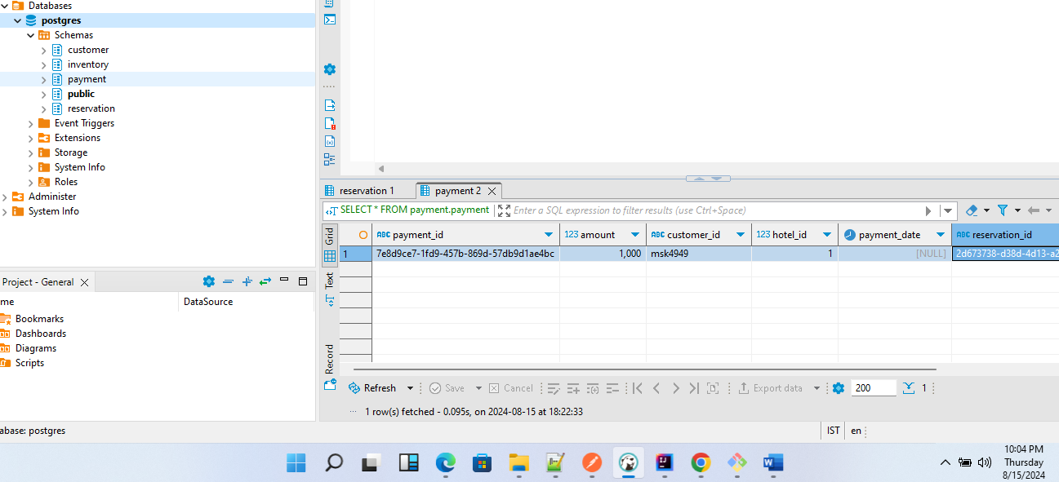

Customer schema:

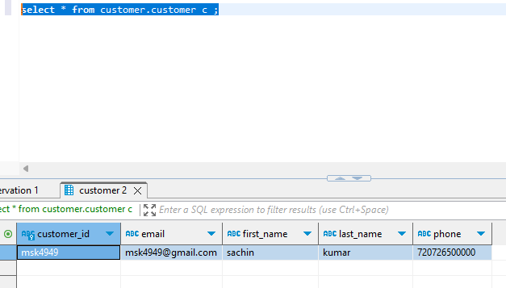

Hotel Management Schema:

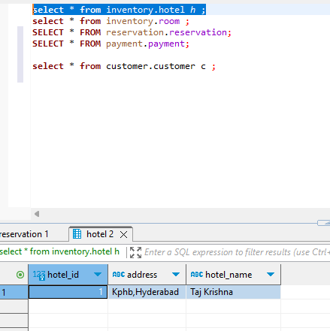

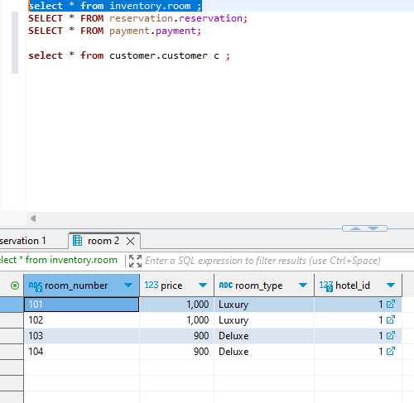

Reservation Schema:

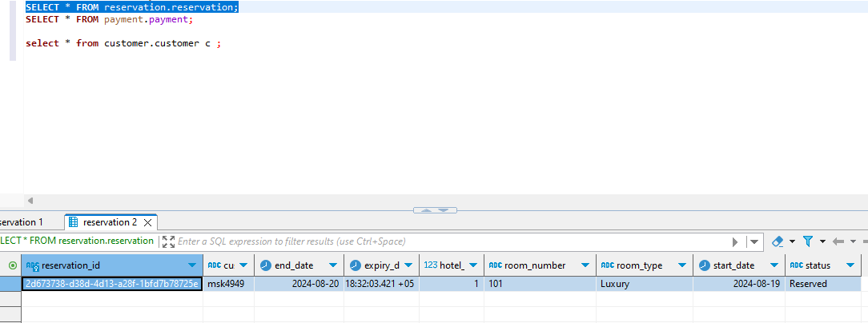

Payment Schema:

